**Register for IBM Cloud**

|  |  |
| --- | --- |
| **Date** | **14 November 2022** |
| **TeamID** | **PNT2022TMID13738** |
| **ProjectName** | **Emerging Method For Early Detection Of Forest Fire.** |
| **MaximumMarks** | **4Marks** |

**AIM**

Toregister for cloud.

# STEPS

1. LogintoIBMCloudwithsmartinternzmailIDandPassword.

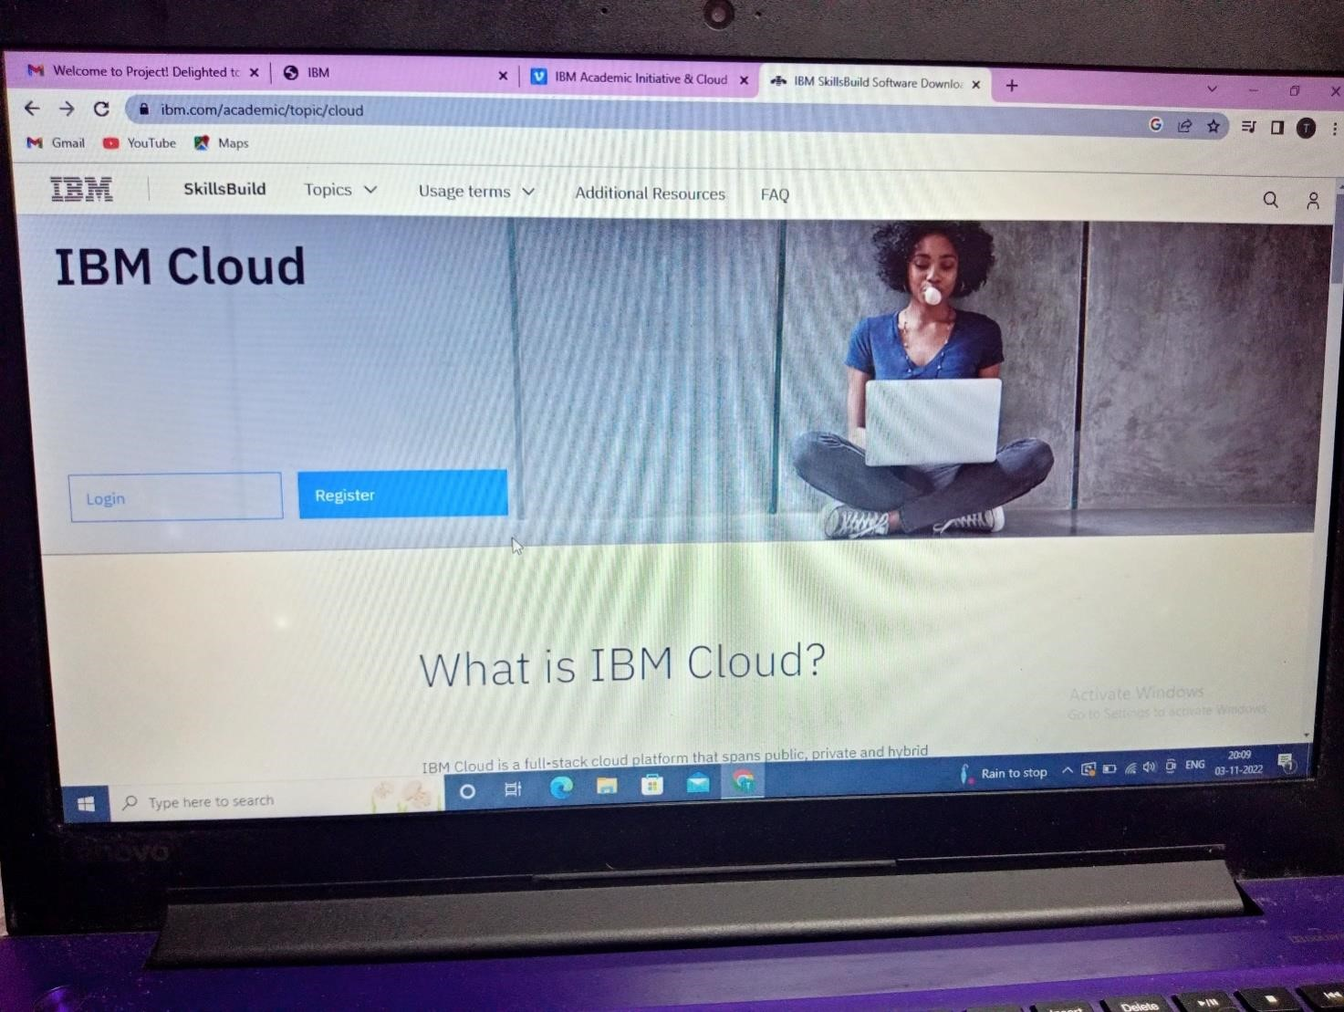

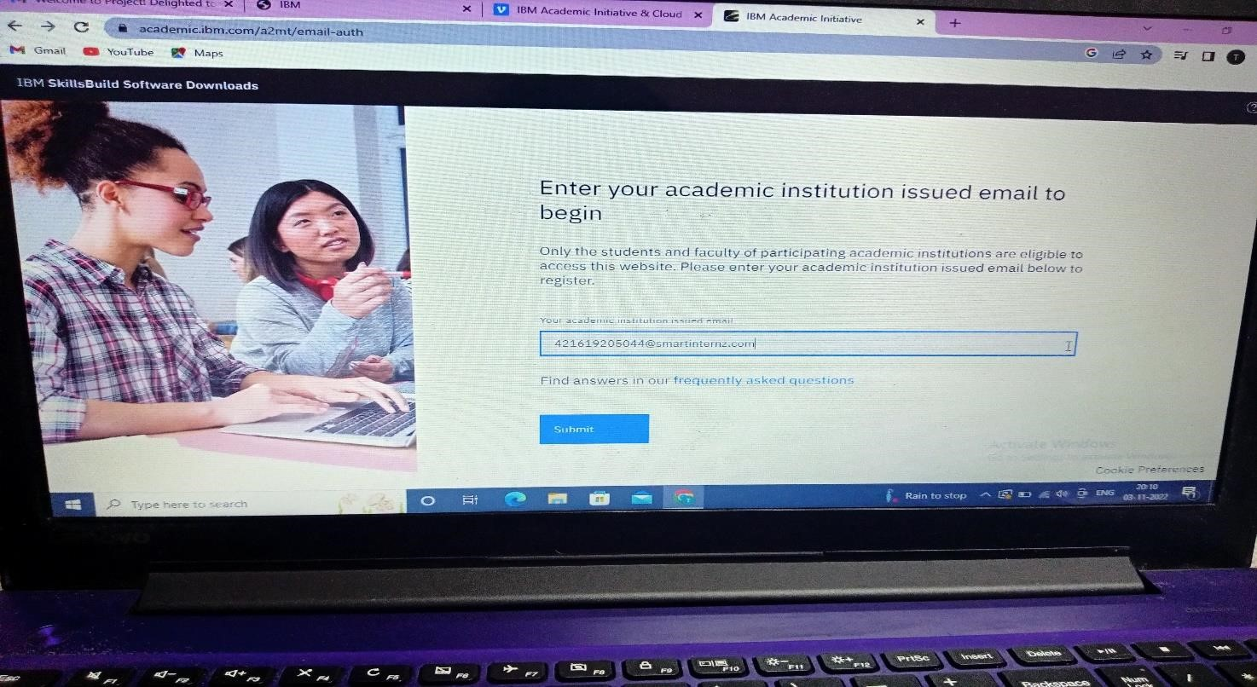

1. Select the IBM cloud.

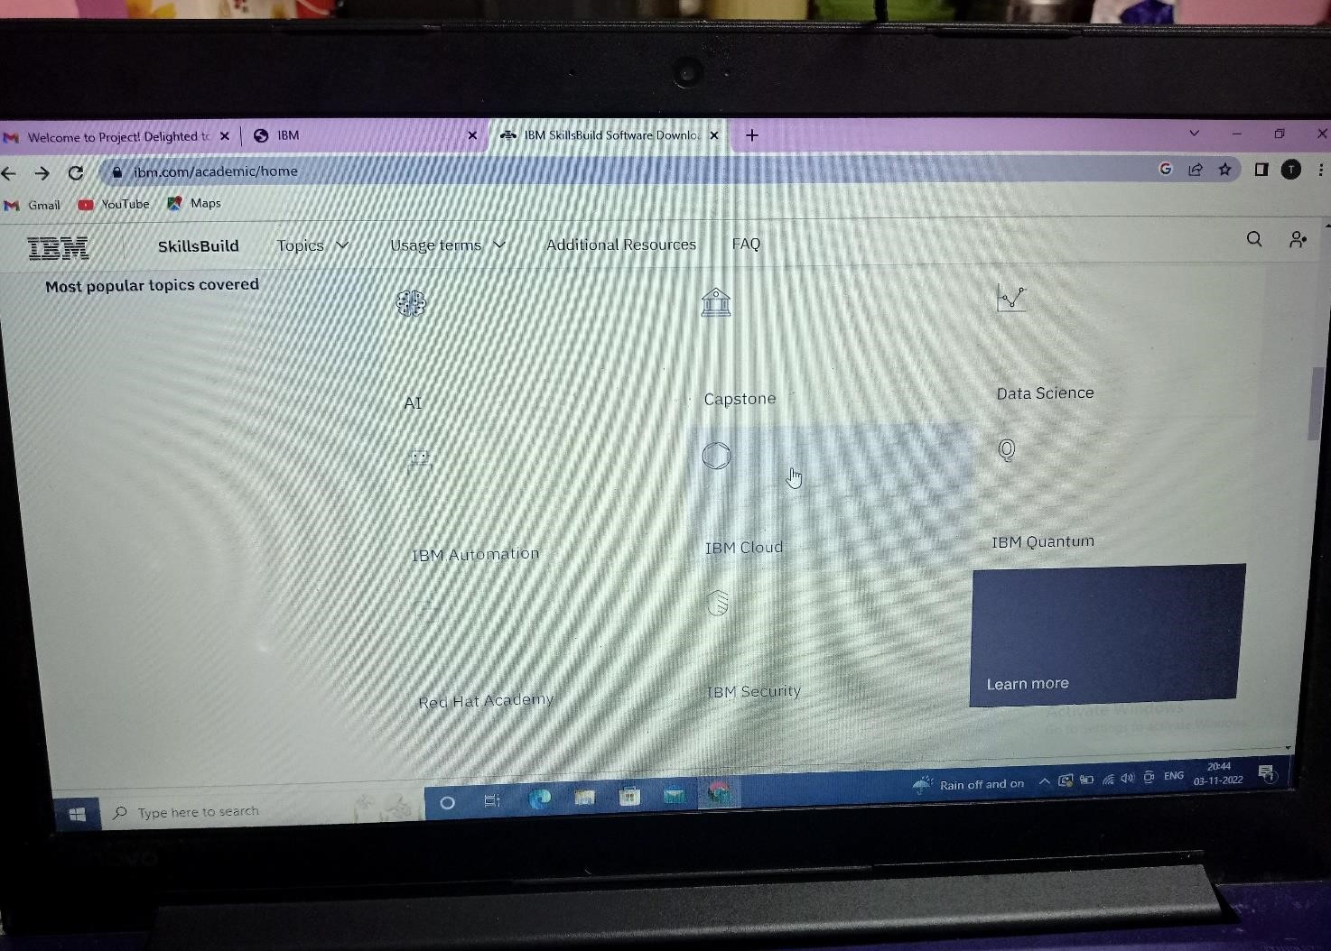

3.Select the Software.

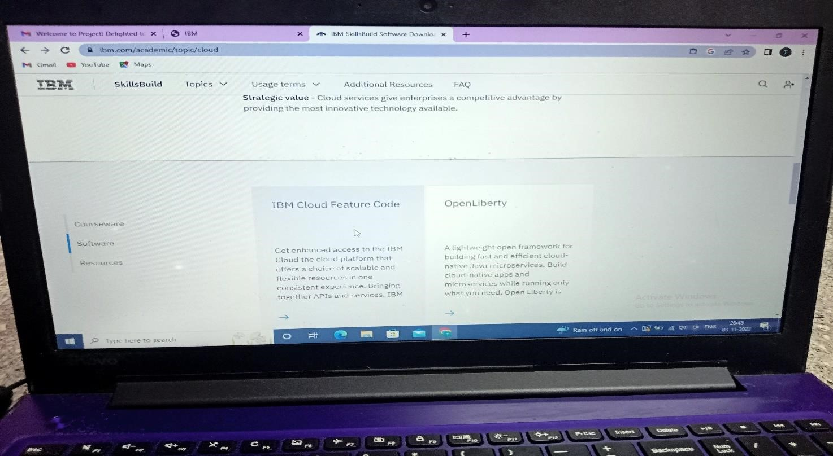

4.Our cloud has been created.

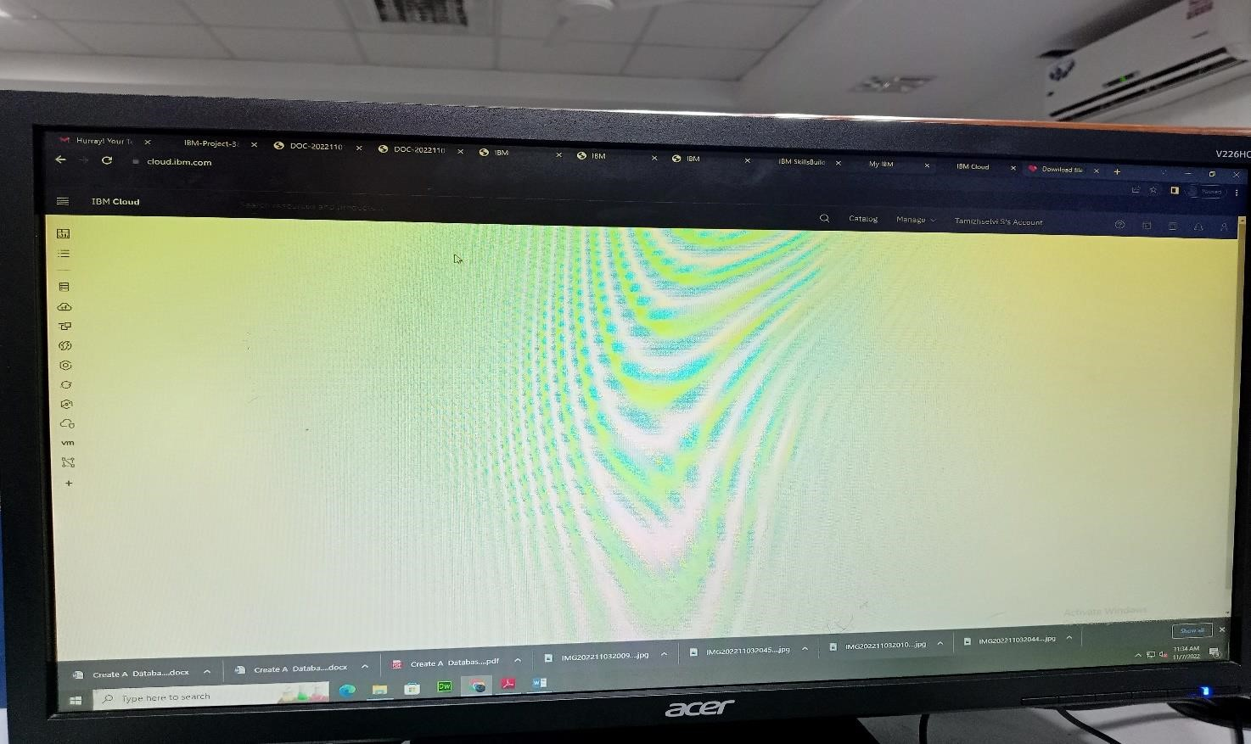

**RESULT**:

AdatabasetostorethelocationdataonCloudDataBasehasbeencreatedsuccessful